Ch 10.

After completing chapter 10, when I ran the program, the ball would just disappear. I assumed it must be going to the wrong way for the screen. After removing the negative sign from the mYVelocity, the ball moved in the correct initial direction.

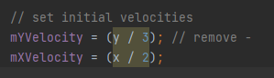

Good code design having both update methods be called the same way for both the bat and ball.

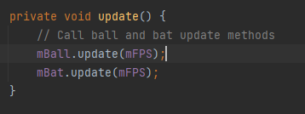

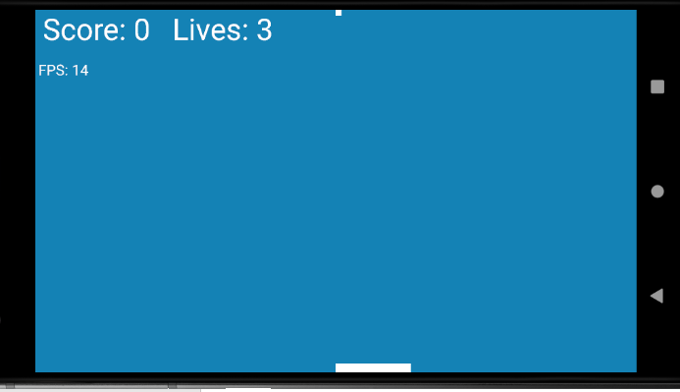

Ch 11.

Obtained sound effects from the book github repository and added to a new assets folder. Despite the red lettering and the spooky question marks, the sounds work properly.

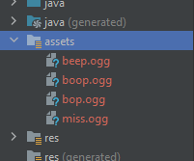

Sounds require version checking because it can be different based on the system.

